

|  |  |
| --- | --- |
| **PROGRAMMING LANGUAGE FINAL PROJECT** | **restaurant management system**  Muneeb Ahmed Khan 66 Usman Sabir 51 |

Table of Contents

**TITLE** 2

**MOTIVATION AND PURPOSE** 2

**TARGETTED AUDIENCE** 2

**FEATURES** 2

**RECOMMENDATION SYSTEM ALGORITHM** 4

**RESTAURANT MANAGEMENT SYSTEM** 5

**MAIN MENU:** 5

**(1)** **USER MENU:** 5

**(i) CUSTOMER DETAIL OPTIONS** 5

**(ii) USER INTERFACE** 6

**(iii) PLACING AN ORDER** 7

**(iv) DEAL OF THE DAY** 8

**(v) REVIEW YOUR ORDER** 9

**(vi) GET RECOMMENDATION** 9

**(vii) MEMBERSHIP INTERFACE** 10

**(a) BUY MEMBERSHIP** 10

**(b) ENTER MEMBERSHIP KEY** 11

**(viii) BILL** 11

**(2) MANAGEMENT MENU** 12

**(i) PASSWORD OPTION** 12

**(ii) GENERATE DEAL OF THE DAY** 12

**(iii) SALES GRAPH** 13

**(iv) CHANGE PASSWORD** 13

**(v)REVIEW MENU** 14

**(vi) PRINT CUSTOMER RECORDS** 15

# **TITLE**

Restaurant Management System

# **MOTIVATION AND PURPOSE**

The main idea behind making a restaurant management program is to provide an efficient ordering and billing mechanism to the customers. We usually see people waiting in long queue waiting for their turns to come to pay the bill or to place an order. This thing motivated us to make such a program which can easily be accessed by a customer in order to place the order easily through this program instead of waiting for their turns in a long queue. Moreover, we wished to add some exciting options for the customers to match their needs according to their budget.

# **TARGETTED AUDIENCE**

The program targets all the food lovers of different ages that frequently visits restaurants to enjoy meals.

# **FEATURES**

**For Customers: -**

* Provides an interactive user-interface to the customer.
* Provides the restaurant’s menu to the customer along with the marked prices.
* Enable customers to order food items.
* They can review and change their orders.
* Maintain record of all the food items they ordered in each of their visits.
* It will suggest the customer about the best deals available through which the user will be able to buy more food for less money
* Update information to the customer regarding the deal of the day generated randomly each day from the list of deals.
* Suggest customer the items he / she may like by analyzing the data of other customers who had ordered a similar kind of items i.e. using recommendation system algorithm.
* Finally, a bill will be generated to the customer with all the details of his / her purchased items.

**For Manager: -**

* The program requires authorization of the manager by prompting to enter a valid password.
* The management interface allows the manager to generate deal of the day containing items generated randomly from the menu.
* Generate sales graph.
* Change password
* Review customer’s record.

# **RECOMMENDATION SYSTEM ALGORITHM**

**Collaborating Filtering Algorithm**

* For each user, count the number of matching items between your profile and the profile of that user.
* Choose the user with the highest number of matches.
* Recommend the items that appear on their list and not on yours.

*The underlying components are the following:*

* The ability to gather input from the user;
* The ability to repeat a task (e.g., asking for the user’s preferred artists, comparing

against stored users’ preferences) many times;

* The ability to store and manipulate data in different ways (e.g., storing the user’s

responses, manipulating the stored users’ preferences); and

* The ability to save data between program runs, and to load saved data (e.g.,

loading the stored users’ preferences from a file, saving the current user’s

preferences to a file).

# **RESTAURANT MANAGEMENT SYSTEM**

## **MAIN MENU:**

The first screen of our program prompts the user to either log in as a user (customer) or as a manager. Press 1 to select “User”, 2 to select “Manager” and 0 to “Exit” the program.

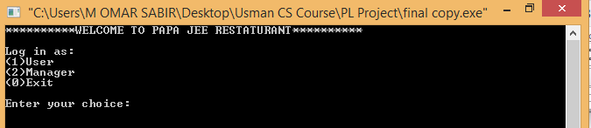

# **USER MENU:**

## **(i) CUSTOMER DETAIL OPTIONS**

To log in as user, you need to provide your details. These details will be used for future purpose (i.e. in getting recommendations).

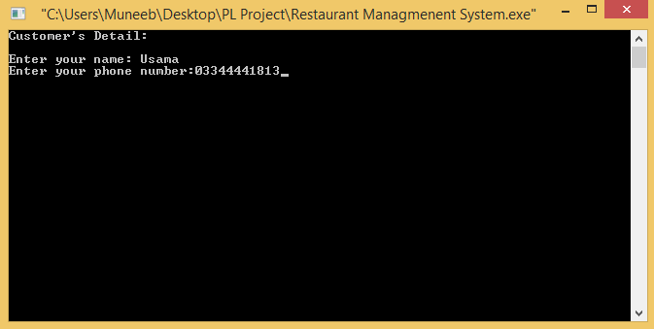

If a user enters an invalid name or phone number i.e. a name consisting of numbers or special symbols, or a phone number with length of digits not equaling 11 or non-numeric input, then it will display an error and asking user to re-enter the details.

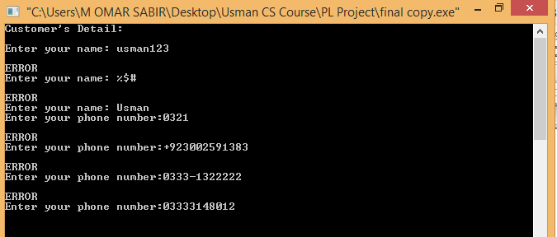

The input phone number as given at the end in the above demonstration will be considered valid.

## **(ii) USER INTERFACE**

You can select from a variety of options in the user interface.

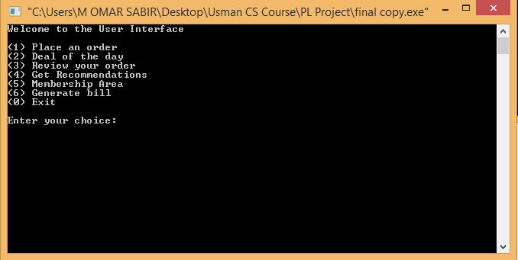

## **(iii) PLACING AN ORDER**

The program prompts the user to press ‘y’ if he/she wishes to order an item from the respective category. Upon pressing ‘y’, the program takes input the item number and the respective quantity.

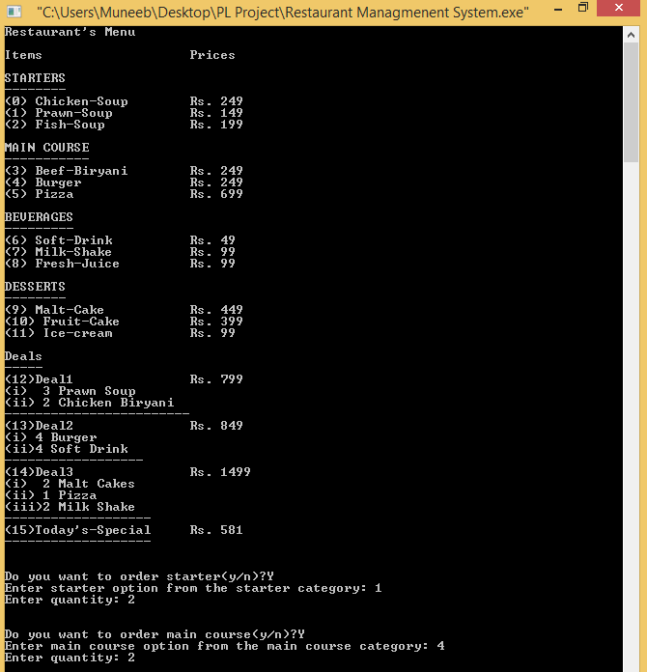

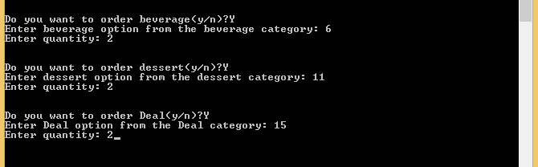

## **(iv) DEAL OF THE DAY**

Prints Today’s special deal. It consists of a pre-decided deal of the day until the manager explicitly generates a random deal from management menu.

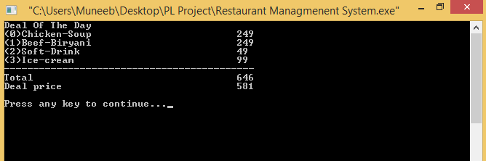

## **(v) REVIEW YOUR ORDER**

The customer can review their order and press ’y’ if he/she wishes to make changes in it. Upon pressing ‘y’, the program will prompt the user to select the item number he/she wishes to change. The program would then ask the user to select a new item for that particular category.

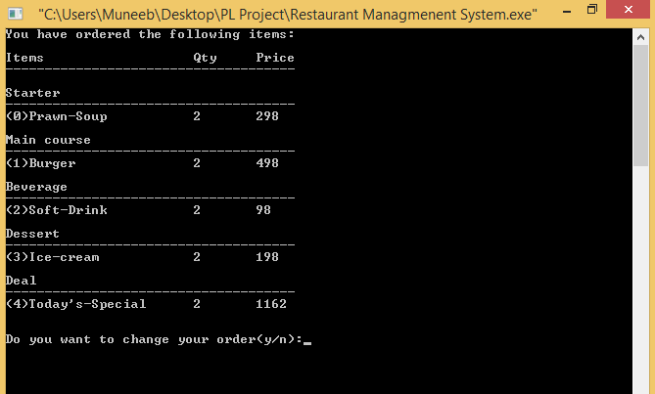

## **(vi) GET RECOMMENDATION**

This feature is based on the collaborative filtering algorithm. It analyzes your previous orders at our restaurant and make predictions using your data and that of other customers. Selecting the most closely matched customer, it will recommend you the dishes he/she ordered which you haven’t.

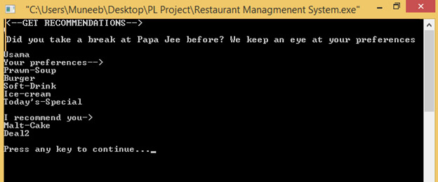

## **(vii) MEMBERSHIP INTERFACE**

Customers can become a member at our restaurant and avail 25% discount on each order.

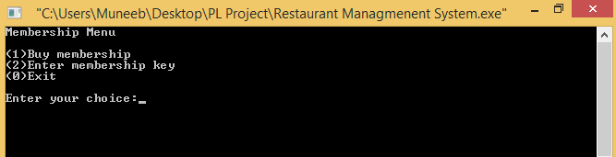

### **(a) BUY MEMBERSHIP**

The program generates a membership id to the customers upon purchasing the membership.

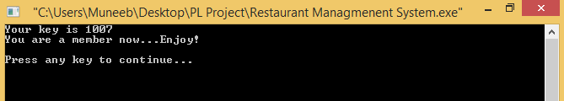

### **(b) ENTER MEMBERSHIP KEY**

The customer needs to enter the key here before generating the bill to avail the special membership discount.

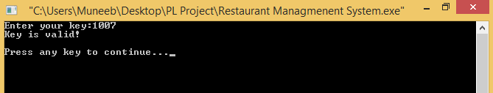

## **(viii) BILL**

A bill is then generated to the customer containing all their details and current date and time.

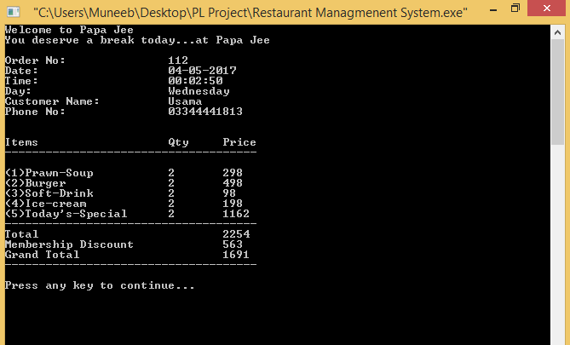

# **(2) MANAGEMENT MENU**

## **(i) PASSWORD OPTION**

The manager need to authorize himself/herself in order to log in.

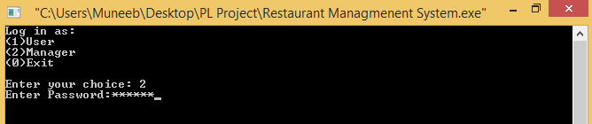

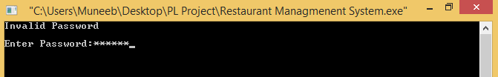

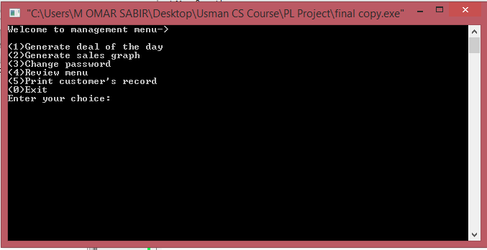

## **(ii) GENERATE DEAL OF THE DAY**

Each time a random deal is generated with a total discount of 10% that can be seen in the user interface.

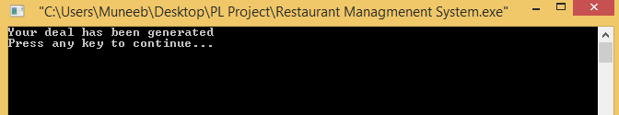

## **(iii) SALES GRAPH**

Generates the sales graph of the total number of sales per item.

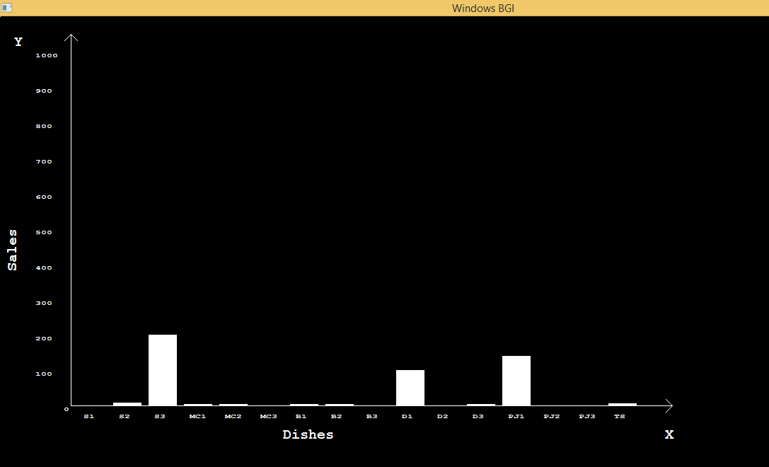

## **(iv) CHANGE PASSWORD**

Provides manager with an option to change the current password. First, the program will prompt the manager to enter the old password. If the old password is valid, the manager can then enter a new password. The program then prints a confirmation message.

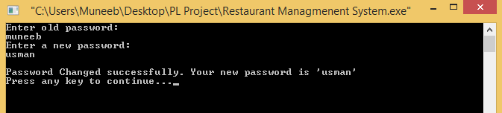

## **(v)REVIEW MENU**

Provides the manager with a list of all the items in the menu and allows the manager to change the prices of a particular item.

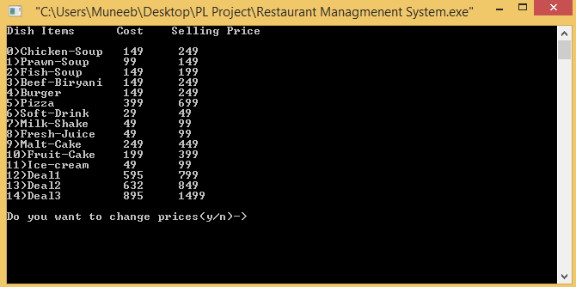

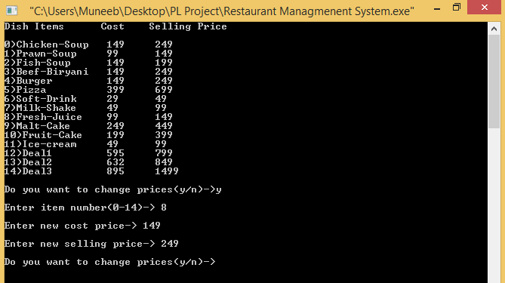

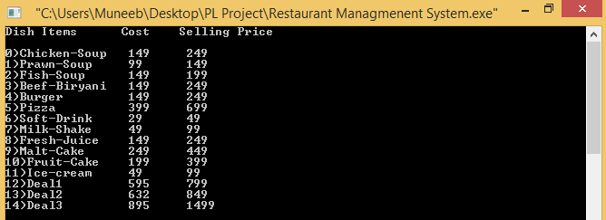

## **(vi) PRINT CUSTOMER RECORDS**

